Ladies of the Lake Quilt Show Country Store
Gretchen Moore moorevw@yahoo.com
Thanks so much for participating in our Country Store.
The Country Store needs a variety of items for sale. We can accept handmade items that are quilt or sewing related. Used items are okay as long as they fall into quilting or craft categories. Now is the time to start gathering or making items for the Country Store. Items sold at the Country Store are 25% to the Guild, and 75% to you. Delivery is Thursday, before the show, unless previously authorized.

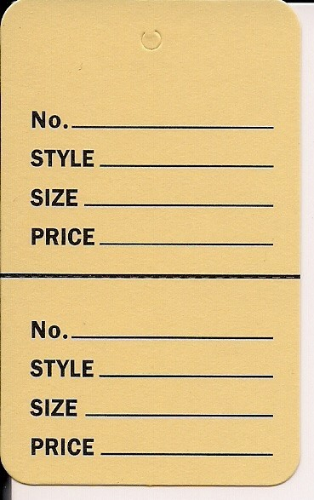
WHAT TO DO?
ABC-2

Ruler

$4.00

ABC-2

Ruler

$4.00

TAGS—Every item will need a tag. Price tags are on our website for you to print out on card stock or heavy paper. Please do not use green paper. Complete the tags as shown:
No. Your 3 Initials, “dash” and line item number from your inventory sheet.
Style Description of item
12”

Size 2 yards, etc.
Price The price of your item

Sunday Savings (Optional)—If you would like your items marked down 50% on Sunday, please give the item an even numbered price. Place a large red dot on both parts of the tag, and on the line item of your inventory sheet. Please do this prior to dropping off your items on Thursday.

Be sure to fill out both portions of the tag. The top of the tag is for the customer and the bottom is cut off and kept for our records. This is how we tell what was sold and to tally the amount to pay you.

INVENTORY SHEETS are required for 75%/25% items. —You MUST complete an inventory sheet with your tagged items. If you need more tags or inventory sheets, print some from our website. Please list all items for sale on the inventory sheets. You may list more than one item n a line if the description and price and the same. Inventory sheets include: Item Number, Description, Price and Quantity.
Make two copies of each sheet. One for your records, and one for the Country Store, to keep track of inventory. The inventory sheets will be kept at the Country Store for any questions about items (price tags falls off, etc.). 75/25 items without an inventory sheet will not be put out for sale.

100% DONATED ITEM—If you have items that you want to donate with all proceeds to the guild, we can accept them in advance and we will store and tag them ourselves. All 100% donations become property of LLQG and will not be returned. Inventory sheets are NOT required for 100% donated items but may be helpful to you if you wish to use the donation for tax purposes.

________________

ON SUNDAY AFTER THE SHOW—Gather your unsold items, check them off on the inventory sheet and take home. The Guild will keep the inventory sheets and make sure we have the bottom tags, for all items sold, to balance our cash register.

PAYMENT: Within a week or so, a check will be mailed to you for 75% of the sold items. NO CASH OUTS. Federal law requires our 501(c)(3) corporate organization to deposit all funds to our checking account and then withdraw by check.
If you listed items donated at 100% on your inventory sheet, you will be able to use this for tax purposes.

Thank you for supporting the Country Store and Ladies of the Lake Quilt Guild.

